**Get started with Git: A Step-by-Step Guide**

# Creating a Github Account

1. Go to the Github website [https://github.com/](https://github.com/%20) and click on the "Sign up" button in the upper right corner.



1. Enter your details to create the account including email, password and username.

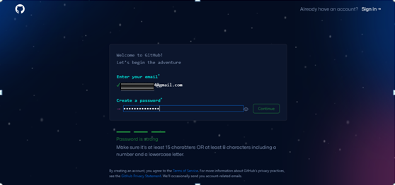

1. Verify your email address by clicking on the link that was sent to you on the email.

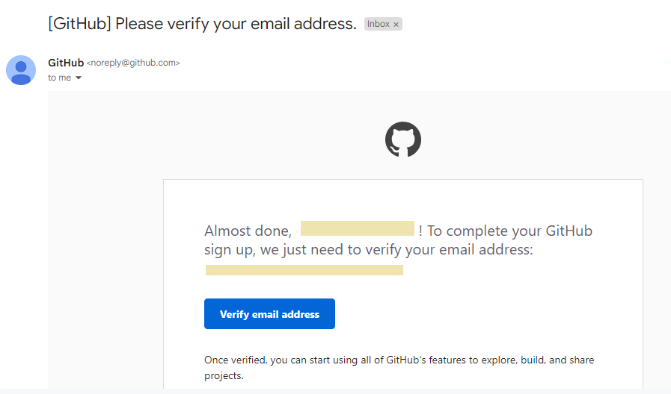

# Installing Git Bash

1. You can download Git Bash from the official Git website for free

<https://git-scm.com/download>

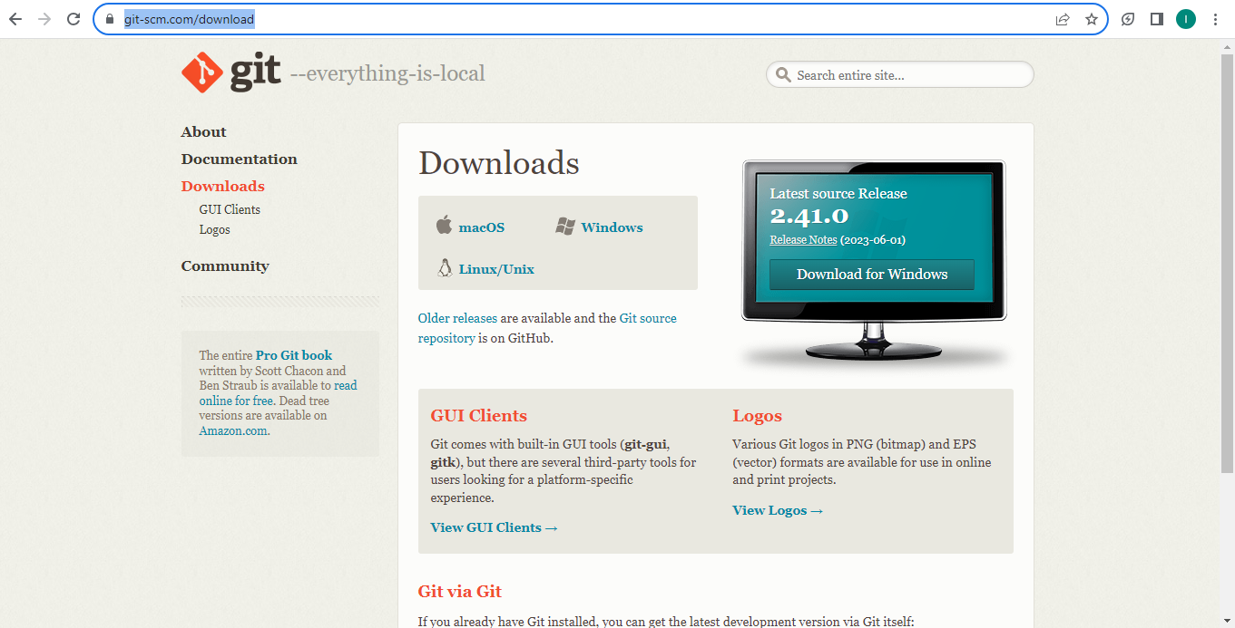

1. Select your operating system and download the installer.

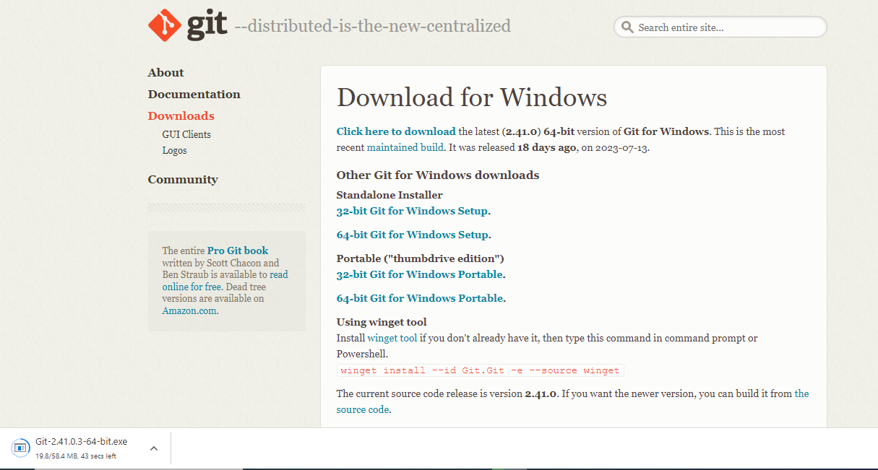

1. Launch the installer once downloaded. Follow the steps below to install git bash.

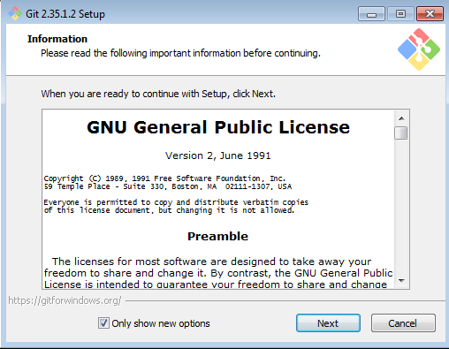

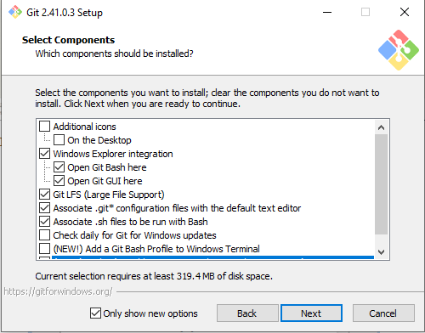

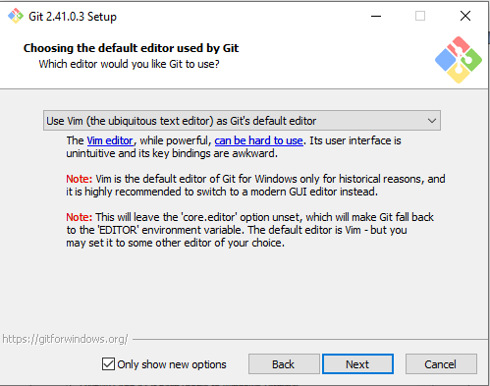

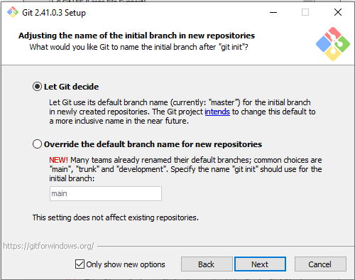

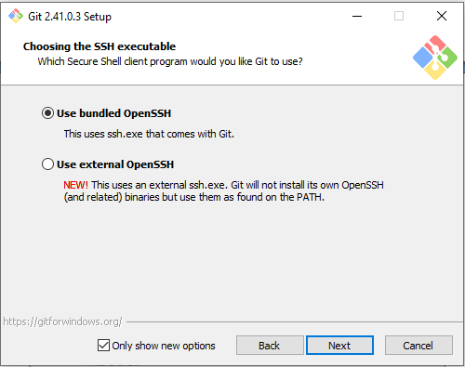

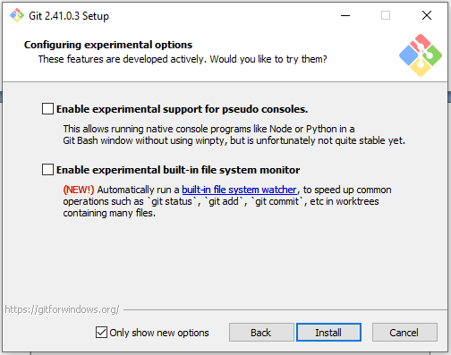

1. Open the command prompt and type **git version** to verify that Git was successfully installed.

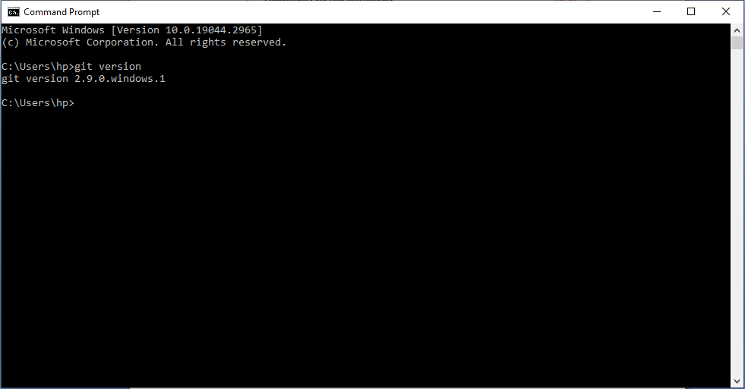

# 3. Setting up Git

# Type cmd or git bash on the search bar. These terminals are used to run git commands.

# 

# To set your Git username, type this in your terminal:

git config --global user.name "<your username >"

1. To set your Git email, type this in your terminal:

git config --global user.email "<youremail@gmail.com>"

# 4. Creating a New Repository

1. Go to your Github account and click on the "New repository" button. Give your repository a name

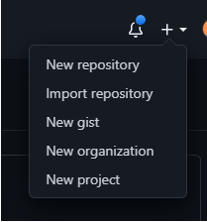

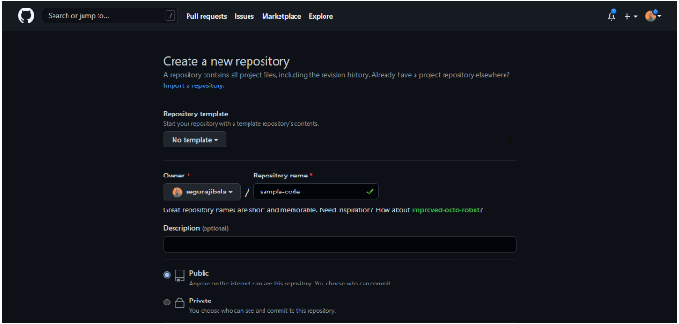

1. Open the folder where you want your project, right click on the screen and select **git bash here** . Type "git init" to initialize the repository

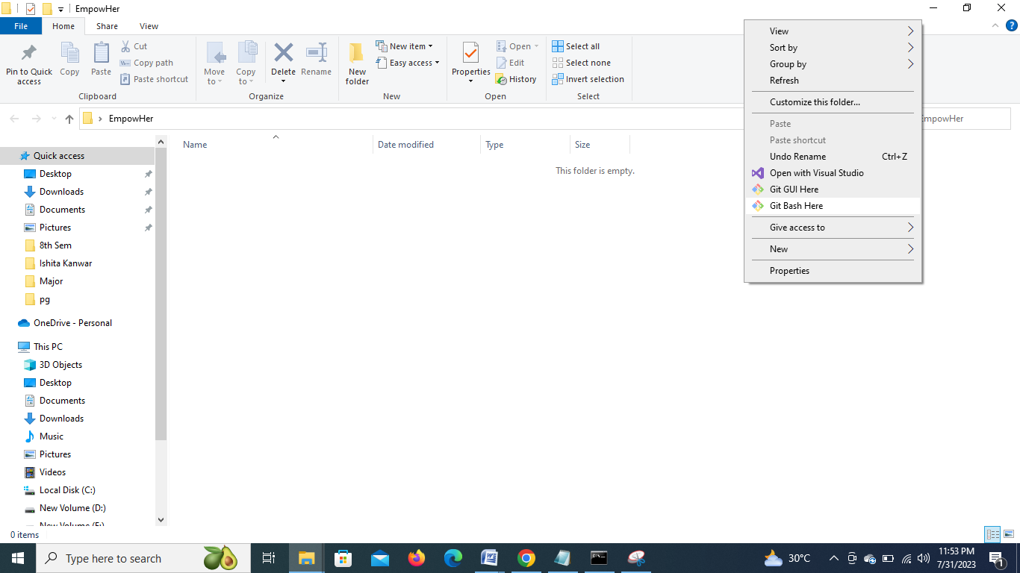

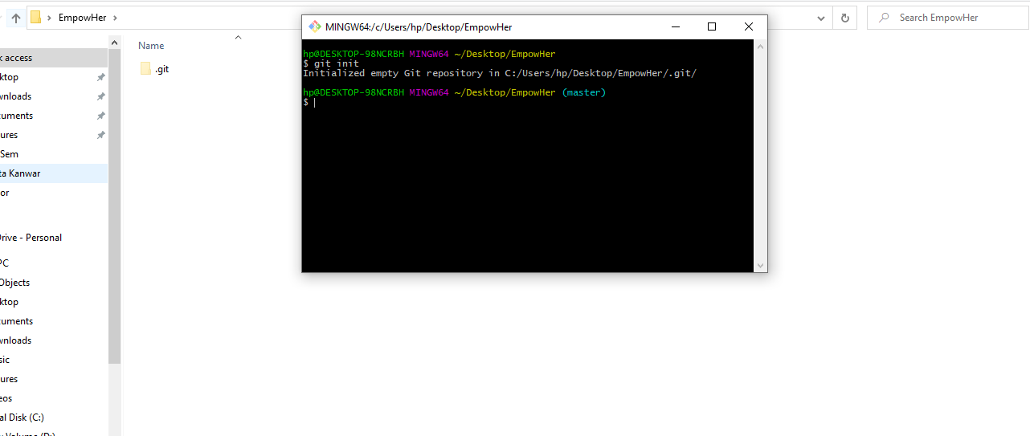

1. Create a new file in the folder where your repository is located.
2. Use the command **git add .** to add all the files in the folder to the staging area.
3. Use the command **git status** to check the files that have been modified.
4. Use the command **git commit -m "Commit message"** to commit the changes and add a message describing what you did.
5. Copy the link of your github repo and use the command **git remote add origin <your repository link>** to connect the local folder to the repository on GitHub.
6. Use the command **git push –u origin** to push the changes to your Github repository.

For more information, refer the links below.

1. <https://www.freecodecamp.org/news/introduction-to-git-and-github/>
2. [https://daily-dev-tips.com/posts/git-basics-your-first-commit-to-github/](https://daily-dev-tips.com/posts/git-basics-your-first-commit-to-github/%20)
3. <https://education.github.com/git-cheat-sheet-education.pdf>